Ideation Phase
Empathize & Discover

Date | 18 June 2026
Team ID
Project Name | SHOPEZ : E-commerce Application
Maximum Marks | 4 Marks

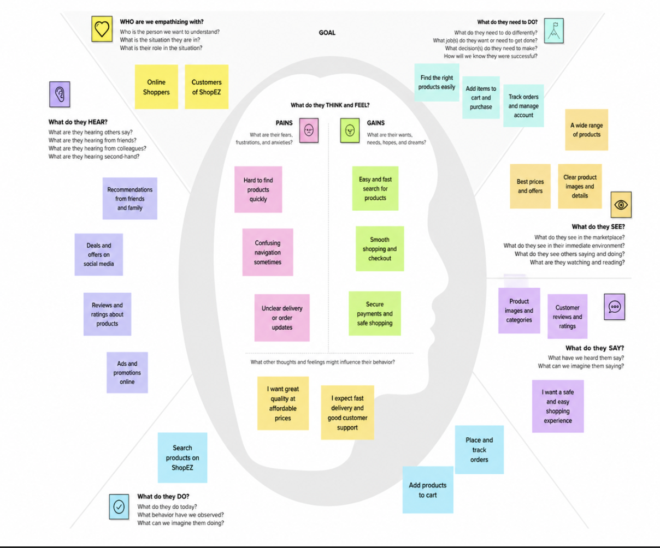
Empathy Map Canvas:

